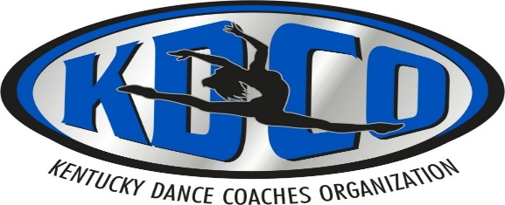

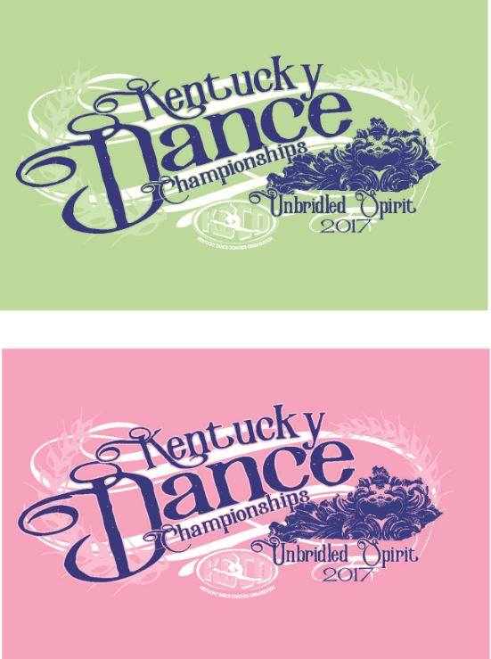

State Apparel Order Form/INVOICE

2017 State Championship t-shirts
Team names on back
Mint Green-Short Sleeve Tee
Pink -Long Sleeve Tee

TEAM NAME & School Name: _____________________________

TEAM COACH & CONTACT NUMBER: ______________________________________

___Mint GREEN Short Sleeve $15
Please mark size quantities:

Youth Small___________ Youth Medium_______ Youth Large______ Youth XL______

Adult Small___________ Adult Medium_______ Adult Large______ Adult XL______ Adult XXL_____ add $3

Qty. X $15=______________Due____________

___Pink Long Sleeve $20
Please mark size quantities:

Youth Small___________ Youth Medium_______ Youth Large______ Youth XL______

Adult Small___________ Adult Medium_______ Adult Large______ Adult XL______ Adult XXL_____ add $3

Qty. X $20=______________Due______________

Total Amount Due:______________
Cash _______________________ Check #_________________

Email orders to: Lensto@msn.com
Make Checks Payable to: DC Screens

