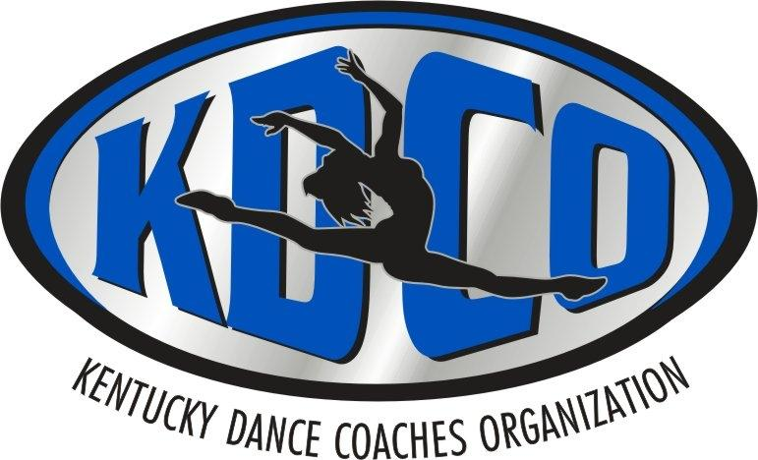
State Competition:
Eminence High School
254 W Broadway, Eminence, KY 40019

Saturday, Feb 25, 2023 - High School
Sunday, Feb 26, 2023 - Middle & Elem School

TEAM NAME & School Name: _____________________________________________________________

HEAD COACH & CONTACT NUMBER TO TEXT: ___________________________________________

HEAD COACH E-MAIL ADDRESS: ________________________________________________________

NUMBER OF TEAM MEMBERS: ___________
Please attach a list of members’ names & must be validated by school administrator.

Please mark one division:

VARSITY______ JV_____ ELEMENTARY______ MIDDLE SCHOOL________

Small(4-10) Med(11-14) Large(15+) Small (4-9) Med (10-14) Large (15+) Small(4-9) Med (10-14) Large(15+)

Please mark style categories you wish to enter:

_____ POM (wristlet: YES NO) _____ JAZZ/LYRICAL ______TEAM/VARIETY
______ HIP HOP _____PROP ______ GAME DAY

State Competition entry fee: $30.00 per competing dancer
~ add 15.00 per additional routine after 2
EXAMPLE: 3 Routines = 45.00 per competing dancer

Make check or money order payable to: KDCO Postmarked by JAN 31st
P.O. Box 1911
Henderson, KY 42419

ALL MONIES ARE NON-REFUNDABLE – STATE COMPETITION WILL GO ON REGARDLESS OF WEATHER CONDITIONS OR ANY OTHER EXTENUATING CIRCUMSTANCES.
USE YOUR BEST JUDGMENT WHEN DECIDING TO TRAVEL.

***In order to be eligible for Grand Champion, teams must compete in at least two categories. Coaches please remember you MUST compete your entire roster in all routines.

First place in each category goes to the team that has the highest score.

Second place in each category goes to the team that has the second highest score.

After all registration forms are received, additional information will be sent via e-mail and posted to the website! www.kydancecoach.org

